Amazon S3 Static Website Hosting — Walkthrough

Overview
This walkthrough documents a third console session in which Rahul created the bucket "aks-protifolio-website-00" specifically to host his personal portfolio page. Unlike a private-storage bucket, this one was built with ACLs enabled and public access unblocked from the start, tagged "My-Portfolio," encrypted with SSE-S3, and then used to upload a single HTML file — my_protofolio.html — which was subsequently made public via an object ACL. Sixteen steps are documented below, one per screenshot, in the order they happened, ending with Rahul opening the object's public URL directly in a browser and seeing his live portfolio page render successfully — the clearest possible proof that the whole setup worked end to end.

Step 1: Opening Amazon S3 and Starting Bucket Creation
Rahul opened the Amazon S3 service home page in the Asia Pacific (Mumbai) region, where the "Create a bucket" panel, pricing details, and an introductory video are shown — the starting point for this new bucket.
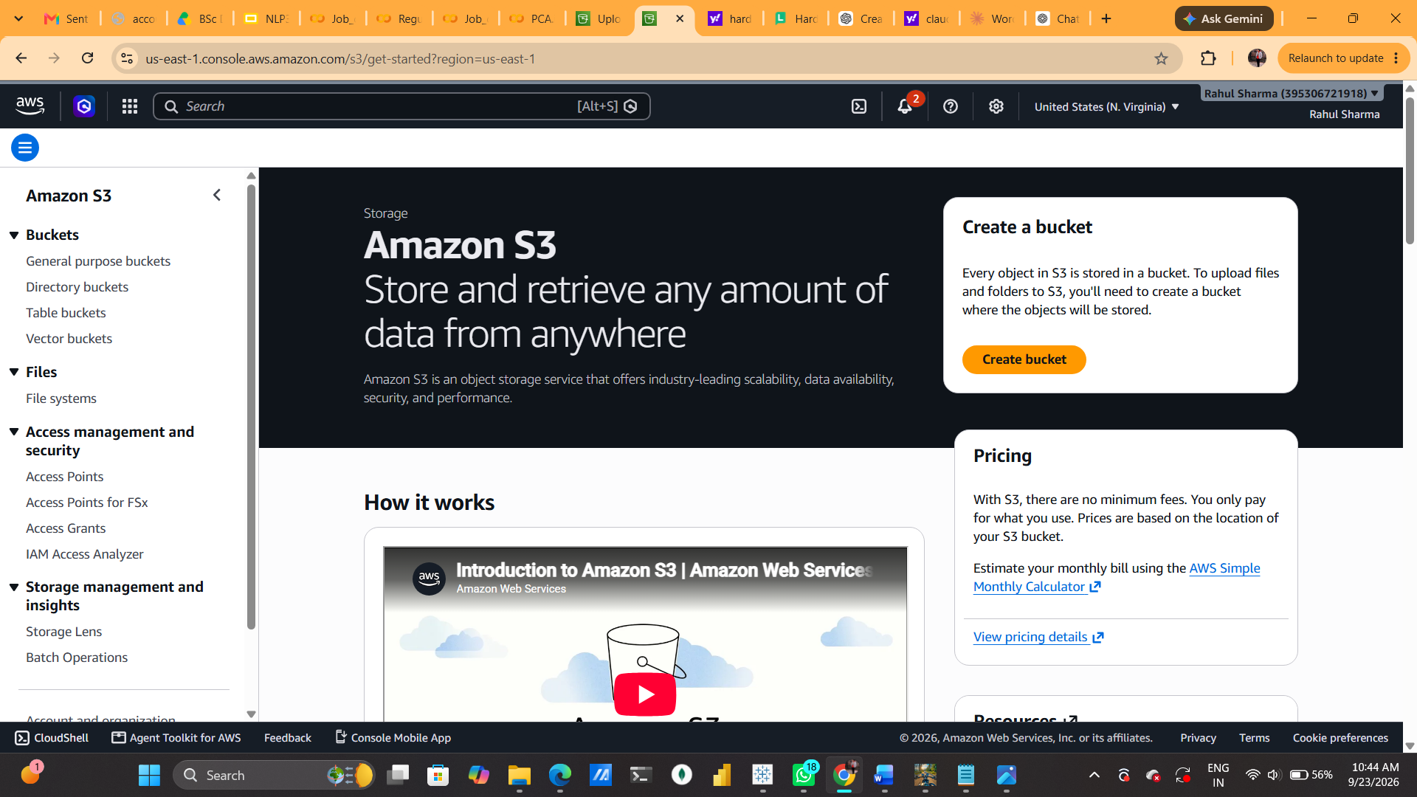

Step 2: General Configuration and Bucket Name
On the Create Bucket page, Rahul confirmed the AWS Region as Asia Pacific (Mumbai) ap-south-1, kept the General Purpose bucket type with the Global namespace, and entered the bucket name "aks-protifolio-website-00" — a name clearly intended for hosting a portfolio site.
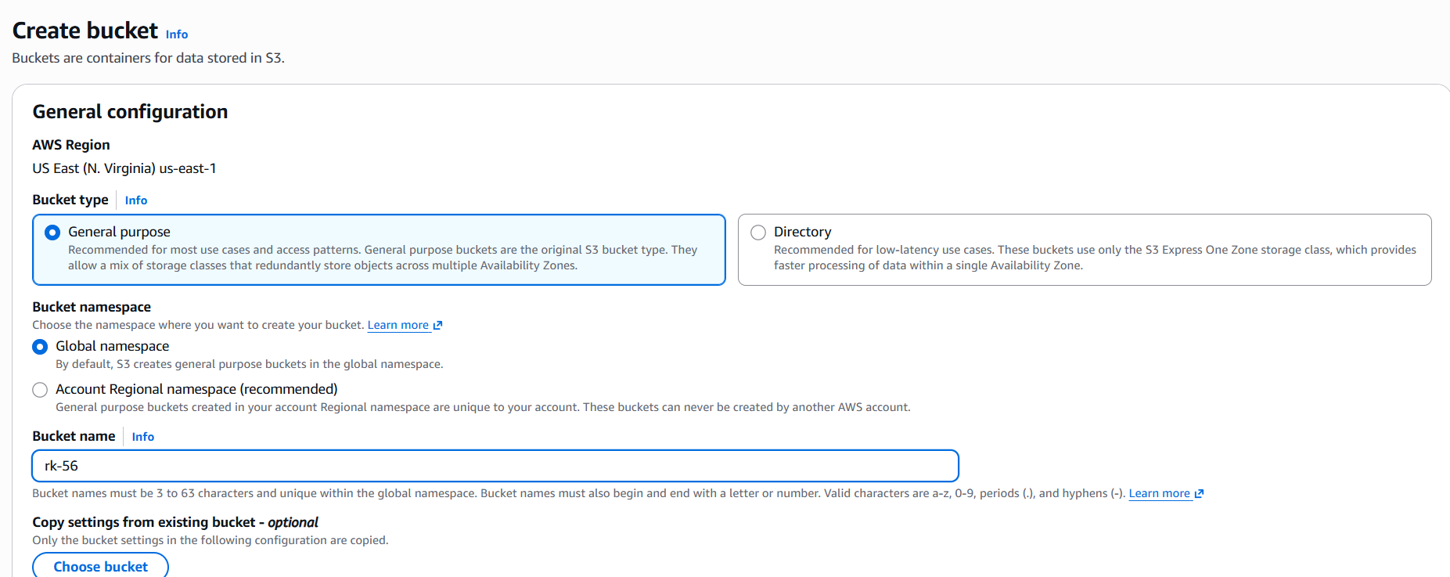

Step 3: Enabling ACLs and Starting Block Public Access
Rahul selected "ACLs enabled" under Object Ownership with "Bucket owner preferred," acknowledging AWS's warning that disabling ACLs is usually recommended. He then reached the Block Public Access section, where all settings began unchecked.
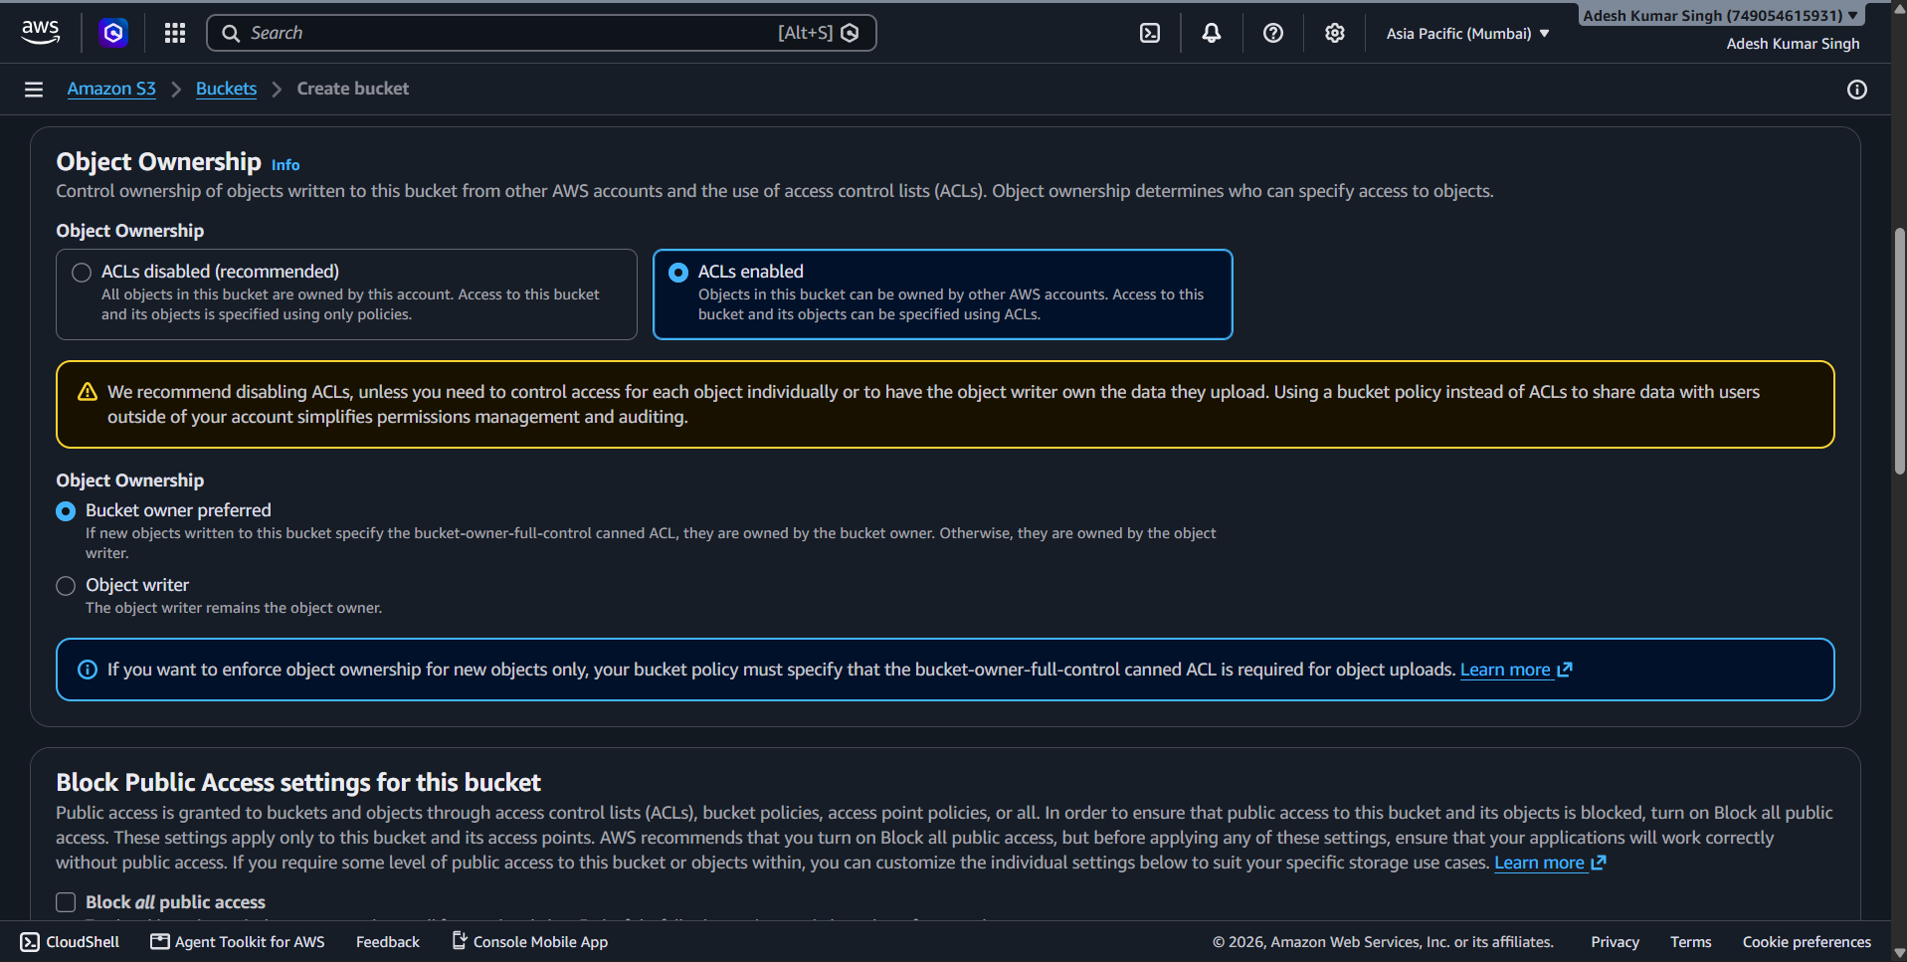

Step 4: Turning Off Block Public Access
Rahul left "Block all public access" and its four sub-settings unchecked, and ticked the acknowledgement box confirming he understood this could make the bucket and its objects public — a deliberate choice, since this bucket was meant to host a public website.
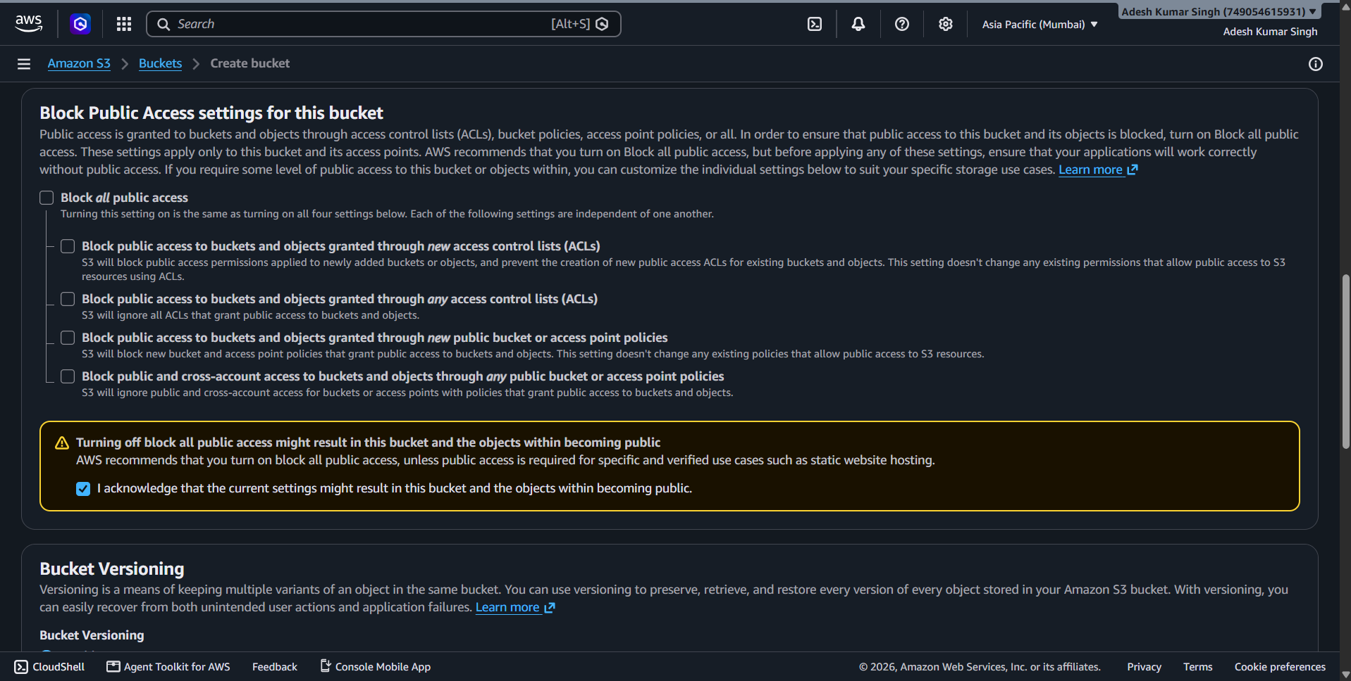

Step 5: Bucket Versioning and Adding a Tag
Rahul kept Bucket Versioning set to "Disable" and added a tag with the value "My-Portfolio" in the optional Tags section, labeling the bucket to reflect its purpose before moving into encryption settings.
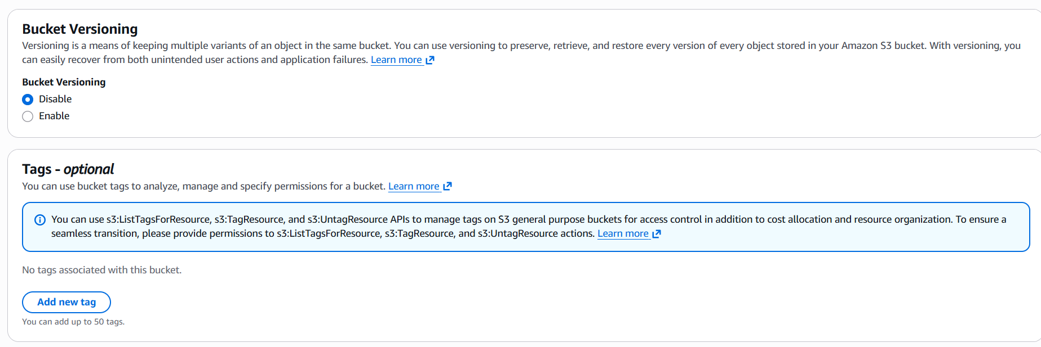

Step 6: Reviewing Tags and Choosing Encryption
With the "My-Portfolio" tag confirmed, Adesh scrolled to Default Encryption and selected "Server-side encryption with Amazon S3 managed keys (SSE-S3)," then enabled the S3 Bucket Key option to reduce KMS request costs.
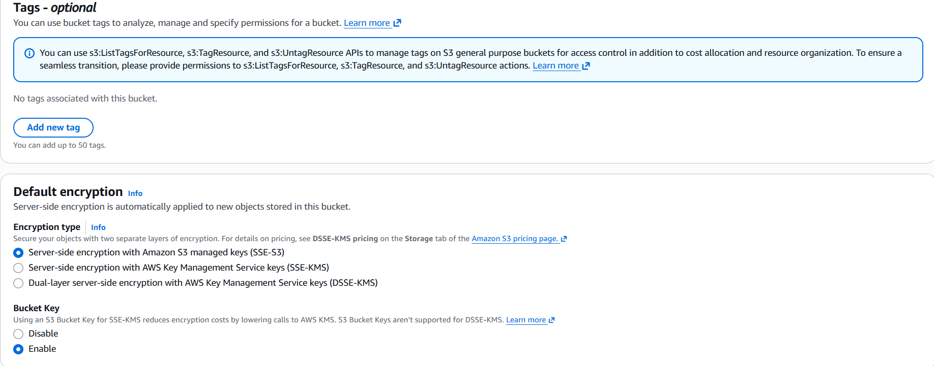

Step 7: Finalizing Encryption and Creating the Bucket
Rahul reconfirmed SSE-S3 encryption with the Bucket Key enabled, left Advanced settings untouched, and clicked "Create bucket" to submit the full configuration.

Step 8: Bucket Created Successfully
A green banner confirmed "Successfully created bucket 'aks-protifolio-website-00'," and the Objects tab showed it was empty (0 objects), ready for the portfolio website file to be uploaded.
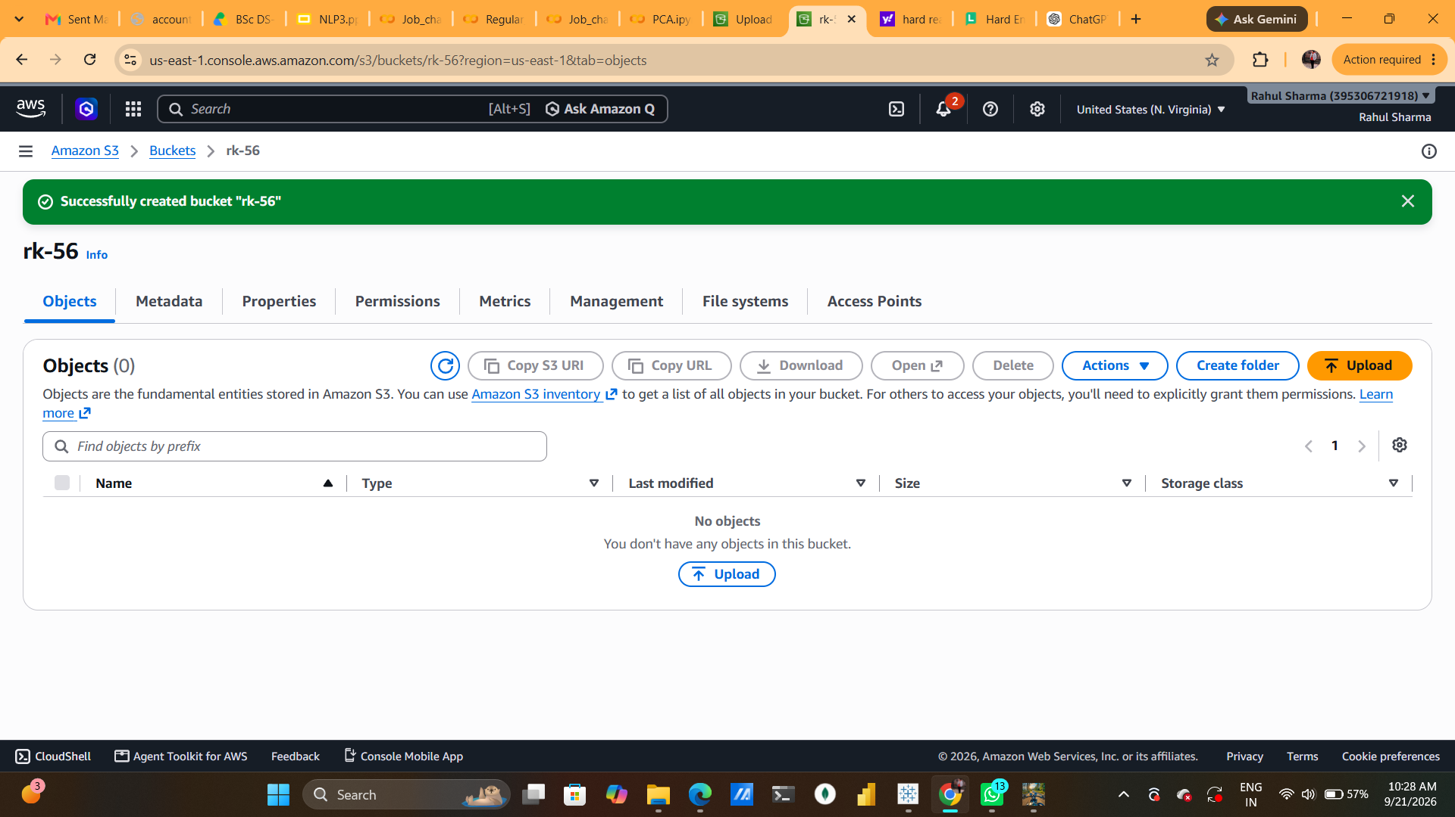

Step 9: Starting the Upload
Rahul opened the Upload page for aks-protifolio-website-00. No files had been added yet, and the destination was confirmed as s3://aks-protifolio-website-00.
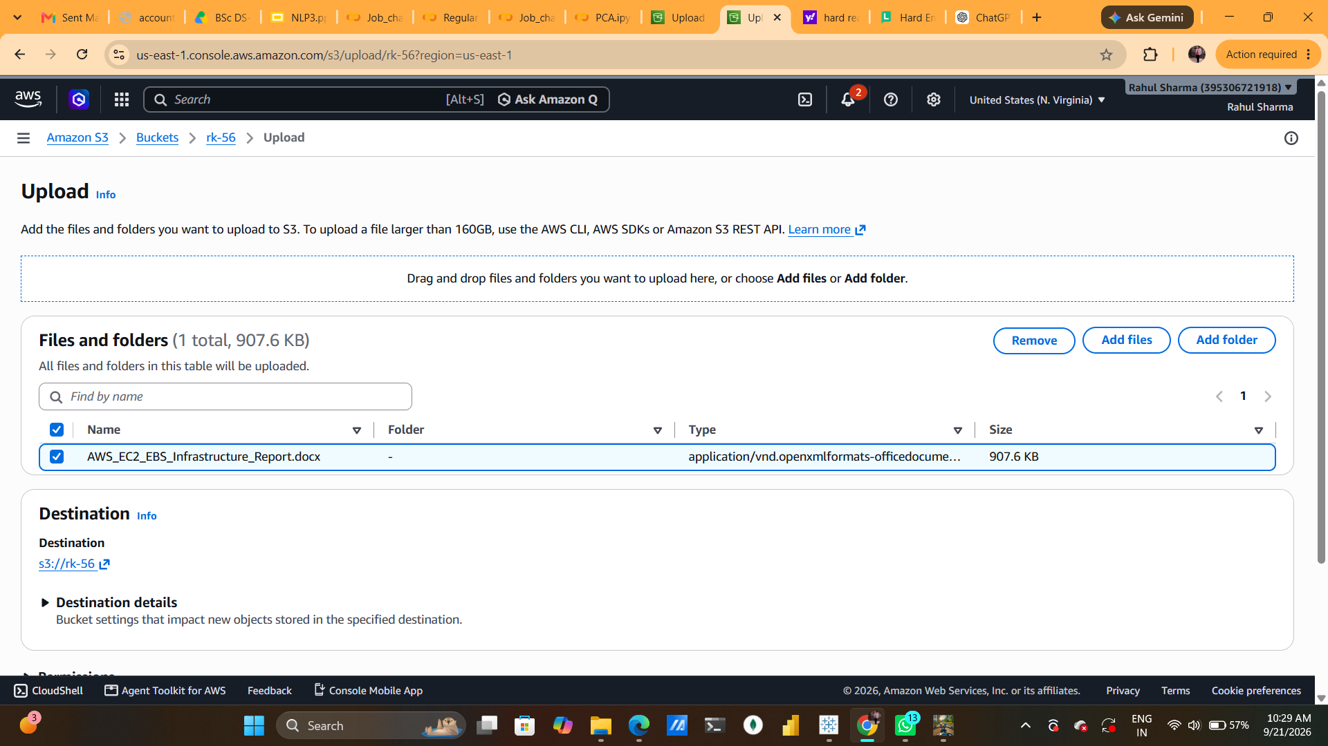

Step 10: Selecting the File to Upload
Rahul added a single file — "my_protofolio.html" (11.6 KB, text/html) — to the upload queue, the HTML file for his portfolio site, before confirming the destination and proceeding to upload.

Step 11: Upload Succeeded
The upload completed successfully — 1 file, 11.6 KB, 100% succeeded, 0 failures — with "my_protofolio.html" marked "Succeeded" in the Files and Folders status table.
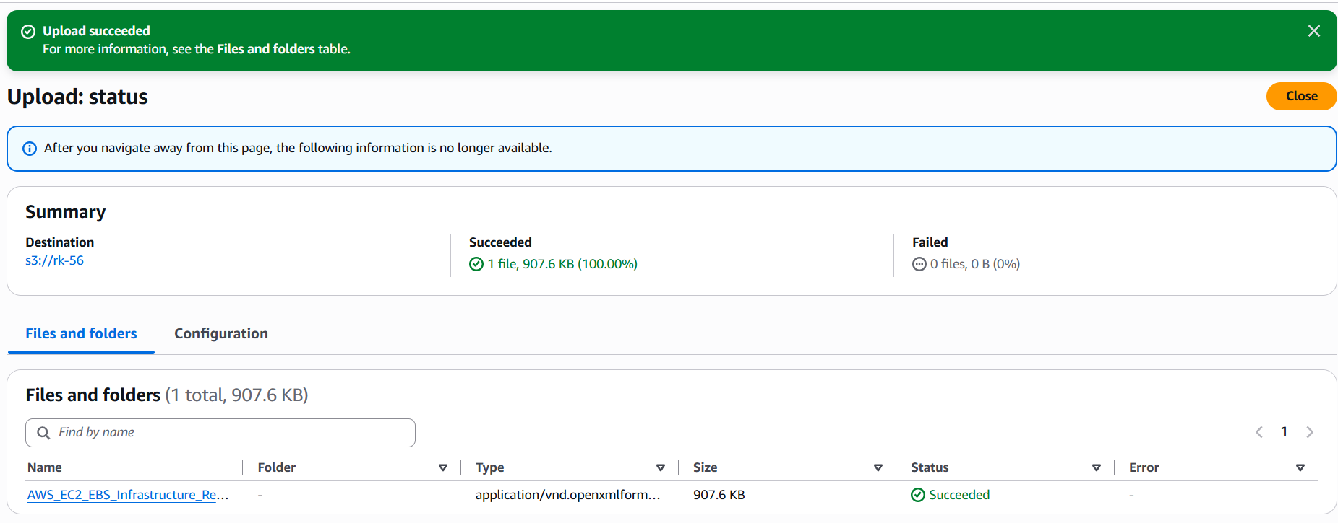

Step 12: Selecting the Object to Make Public
Back in the bucket's Objects list, Rahul selected "my_protofolio.html" and opened the Actions menu, choosing "Make public using ACL" to grant public read access so the HTML file could be viewed as a live website.
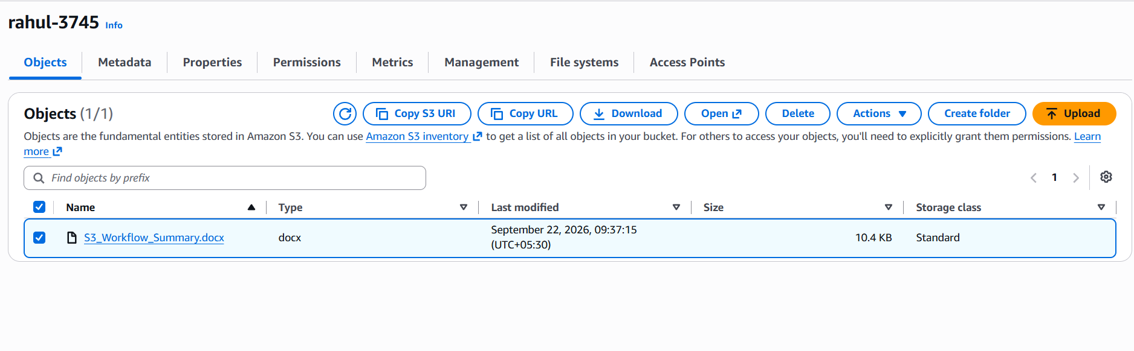

Step 13: Confirming the Object for Public Access
The Make Public page listed the specified object, "my_protofolio.html" (11.6 KB), along with AWS's warning that anyone in the world would be able to access it once public read access took effect. Rahul clicked "Make public" to confirm.
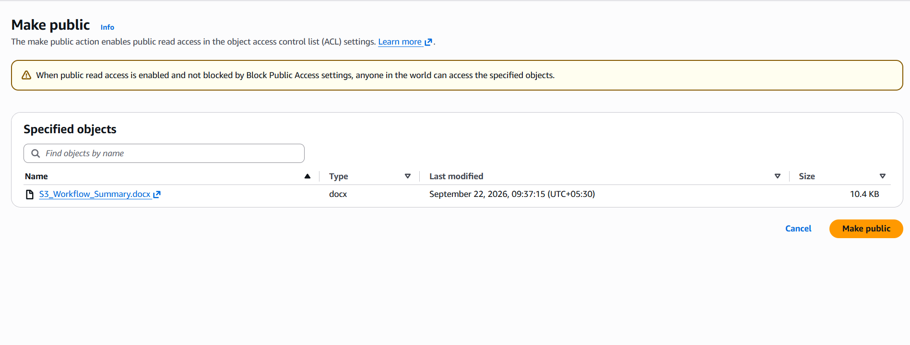

Step 14: Public Access Applied Successfully
A success banner confirmed the change — 1 object, 11.6 KB, successfully edited for public access with 0 failures — meaning my_protofolio.html was now publicly readable.
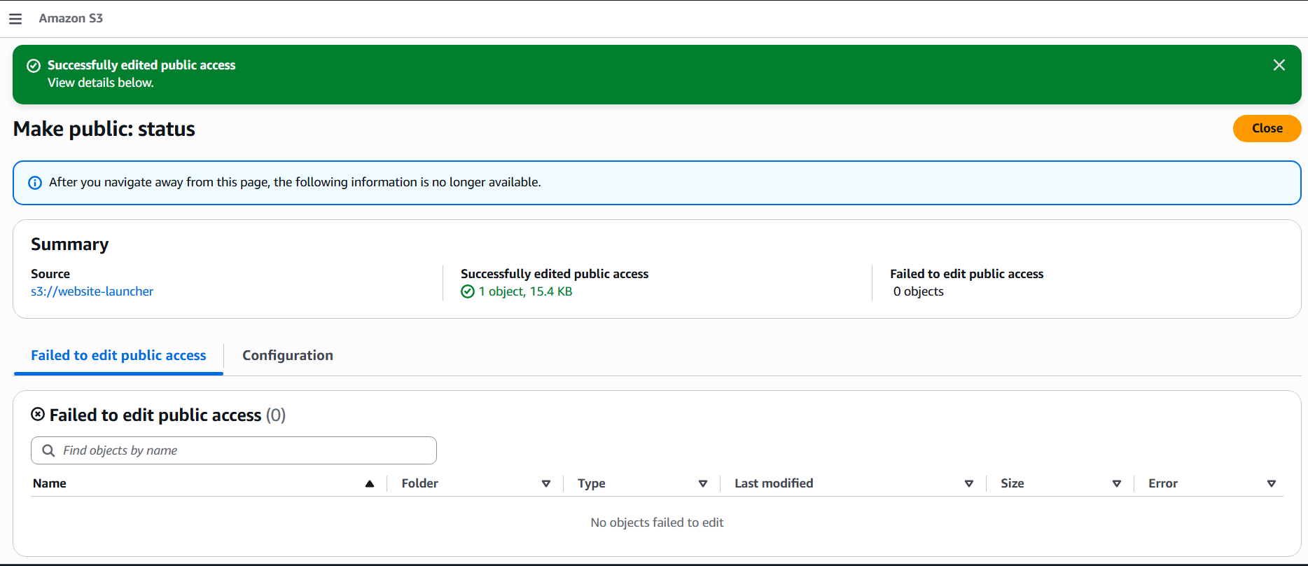

Step 15: Viewing the Object's Properties
Rahul opened my_protofolio.html's Properties page, reviewing its S3 URI, Amazon Resource Name (ARN), entity tag, size (11.6 KB), and — most importantly — its public Object URL on the aks-protifolio-website-00.s3.ap-south-1.amazonaws.com domain.
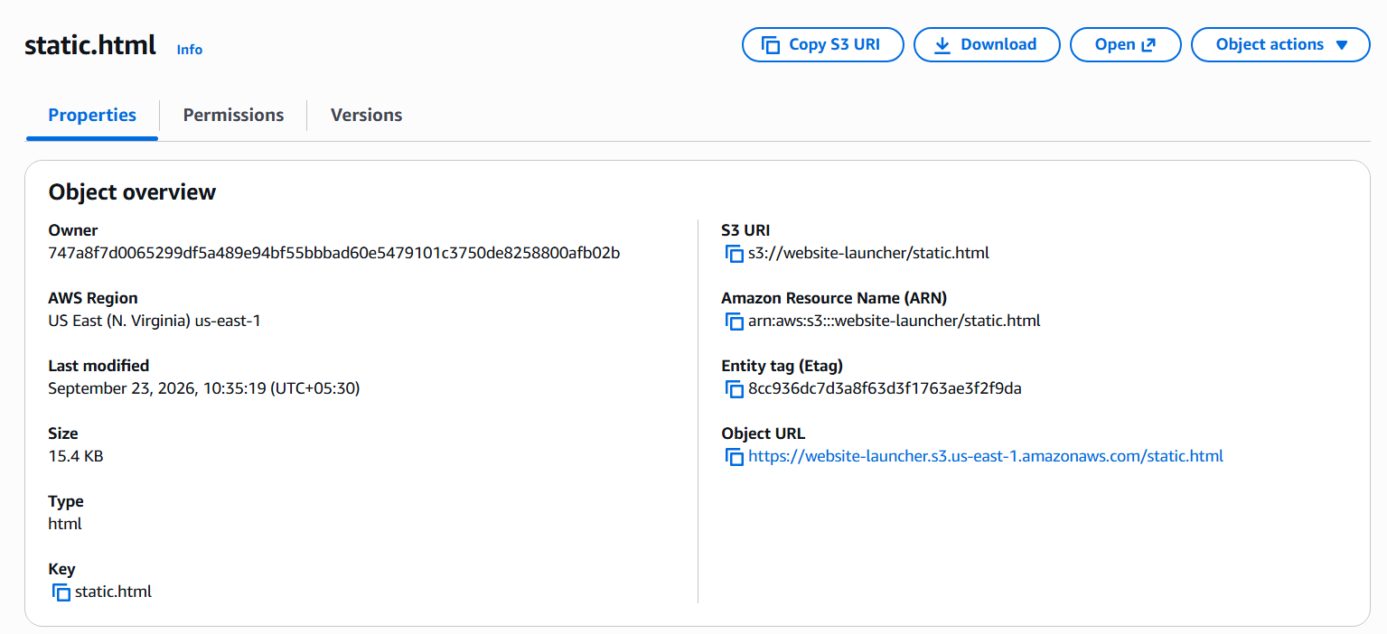

Step 16: Verifying the Live Portfolio Website
Finally, Rahul opened the Object URL in a new browser tab, and the portfolio page loaded successfully — "Hi, I'm Rahul Sharma, BSc Data Science Student | Python Developer | Building Intelligent Systems" — confirming the file was genuinely live and publicly accessible straight from the S3 bucket.
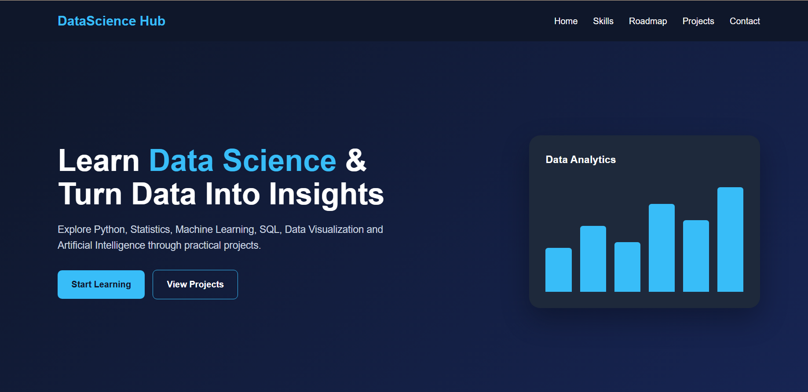

Closing Summary
Between 10:38 and 10:49 on September 23, 2026, Rahul went from an empty S3 console to a live, publicly viewable personal portfolio website — creating aks-protifolio-website-00 with public access intentionally unblocked, uploading a single HTML file, granting it public read access via an object ACL, and then confirming, in his own browser, that the page actually rendered at its S3 object URL. Sixteen screenshots, sixteen steps, one continuous trace of turning a plain S3 bucket into a working public web page.

